Statement
INSERT INTO Facility (FacNo, FacName)
VALUES ('F104','Swimming Pool');

Before (4 rows)
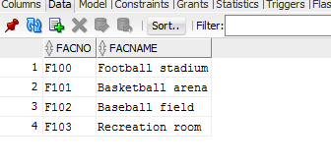

After(5 rows)
